|  |
| --- |
| ASE TEAM 1  USER DOCUMENTATION HUSACCT –GENERAL GUI & CONTROL  June 24, 2013 |

|  |
| --- |
| THIJS SCHALK - DONOVAN DE KUIPER - BART STEIJLEN  LEO WAKELKAMP - COEN VAN DRIEL |

CONTENTS

INTRODUCTION 2

GETTING STARTED 3

CREATING A WORKSPACE 3

SAVING A WORKSPACE 4

OPENING A WORKSPACE 5

APPLICATION ANALYSIS HISTORY 6

ACTION LOG 7

# INTRODUCTION

This document will contain the user documentation regarding the general graphical user interface and control of HUSACCT.

# GETTING STARTED

## CREATING A WORKSPACE

1. To create a workspace, go to file => New workspace.   
2. Choose a name for you workspace and select "Analyse Application".   
3. Give the application you want to analyse a name.  
4. Select the programming language.  
5. Give your application a version number (not the Java version number).  
6. Click on "Add" and select your project you want to analyse.  
7. Your workspace settings should look like something like this:

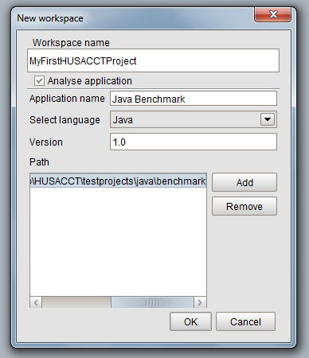

8. Click "OK" and HUSACCT starts analysing your selected project.   
9. During this process, you can start defining your architecture in the define screen that is also opened by HUSACCT.

## SAVING A WORKSPACE

1. To save a workspace, go to file => Save workspace   
2. Select the file type (currently only xml available)  
3. Choose a path using the "Browse" button  
4. There are a couple of options available:  
- Compress: Compresses the file to lower the required disk space  
- Password protection: Protect the file with a password, this makes the file unreadable when opening with a text editor  
5. Click "Save" and your workspace will be saved

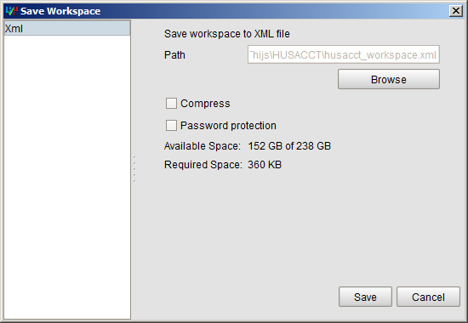

## OPENING A WORKSPACE

1. To open a workspace, go to file => Open workspace   
2. Select the file type (current only xml available)   
3. Choose the file you want to open using the "browse" button   
4. Click open   
5. When the file is password protected, you will be prompted for a password

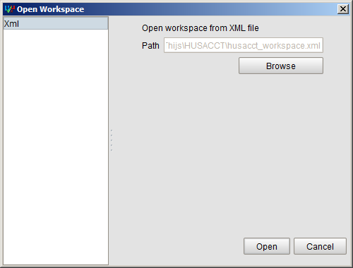

# APPLICATION ANALYSIS HISTORY

After analyzing any source code, HUSACCT saves information about the analysis in its App Data folder. This allows you to view the evolution of the software while your optimizing your code to get as few violations as possible. This analysis information can be found under Analyse -> Analysis History and looks like this:

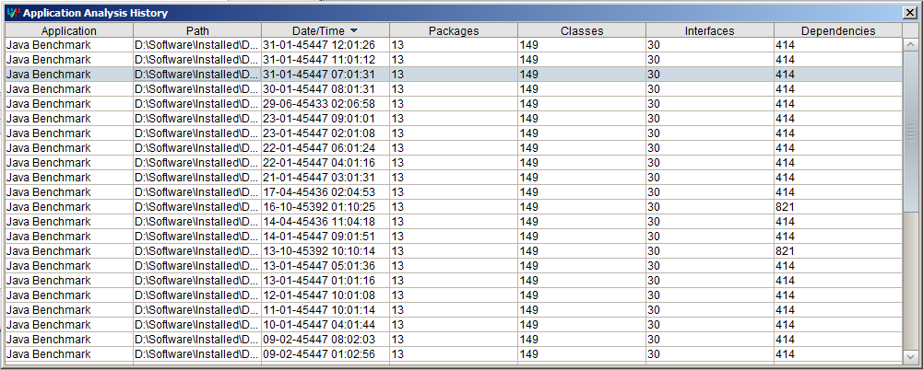

# ACTION LOG

The action log will show primary actions you've taken in HUSACCT. Say for example you've analysed a project. After analysing you'll see a message appear in the Action Log showing you the time you've analysed. The same goes for defining or validating. It is disabled by default and can be enabled in Tools -> Options -> General.

